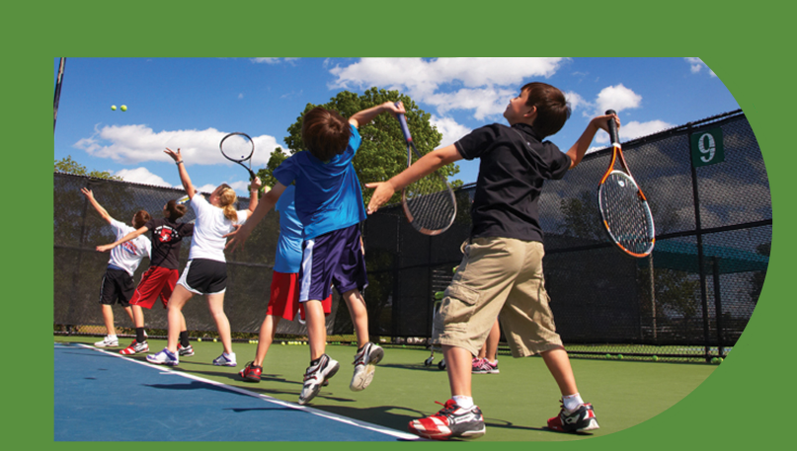
JUNIORS

TENNIS REGISTRATION FORM
Please return completed form to the Tennis Desk.
Membership Eligible Classes:
(Please make a check mark by the classes you would like to sign up for.)
2 Days: 10%, 3+: 20% OFF, Sibling: 10%
Red Ball: (ages 4-7)
√ | DAY | TIME | PROGRAM FEE | DROP IN FEE
 | Tuesday | 4:30 – 5:30 pm | $20/ Day | $25/ Day
 | Thursday | 4:30 – 5:30 pm | $20/ Day | $25/ Day
 | Saturday | 9:00 – 10:00 am | $20/ Day | $25/ Day
Orange Ball: (ages 7-10)
√ | DAY | TIME | PROGRAM FEE | DROP IN FEE
 | Monday | 5:30 - 7:00 pm | $25/ Day | $30/ Day
 | Wednesday | 5:30 - 7:00 pm | $25/ Day | $30/ Day
 | Friday | 5:30 - 7:00 pm | $25/ Day | $30/ Day
 | Saturday | 10:00– 11:30 am | $25/ Day | $30/ Day

Green: (ages 10-12)
√ | DAY | TIME | PROGRAM FEE | DROP IN
 | Monday | 5:30 - 7:00 pm | $25/ Day | $30/ Day
 | Wednesday | 5:30 - 7:00 pm | $25/ Day | $30/ Day
 | Friday | 5:30 - 7:00 pm | $25/ Day | $30/ Day
 | Saturday | 10:00– 11:30 am | $25/ Day | $30/ Day

Development (UTR 0-1)
√ | DAY | TIME | PROGRAM FEE | DROP IN
 | Tuesday | 5:30 – 7:00 pm | $25/ Day | $30/ Day
 | Thursday | 5:30 – 7:00 pm | $25/ Day | $30/ Day
 | Friday | 5:00 – 6:30 pm | $25/ Day | $30/ Day
 | Saturday | 11:30– 1:00 pm | $25/ Day | $30/ Day

Performance (UTR 4+)
√ | DAY | TIME | PROGRAM FEE | DROP IN
 | Monday | 5:00 – 7:00 pm | $30/ Day | $35/ Day
 | Tuesday | 5:00 – 7:00 pm | $30/ Day | $35/ Day
 | Wednesday | 5:00 – 7:00 pm | $30/ Day | $35/ Day
 | Thursday | 5:00 – 7:00 pm | $30/ Day | $35/ Day
 | Friday | 5:00 – 7:00 pm | $30/ Day | $35/ Day

TENNIS REGISTRATION FORM
Participant Information

First Name Last Name Member Number DOB Gender

Address City State Zip

Phone Player e-mail

Parent or Guardian Name Parent/Guardian e-mail Phone

*Approval for Performance required by Andres.
NOTICE: A registration form is required from every player. It needs to be signed by a parent or guardian prior to starting the class. All classes require a 30-day cancellation notice to end billing. No refunds will be issued for missed classes. Sessions can be made-up by contacting Andres (andreso@impactactivities.com) or To calculate monthly class fees, multiple the number of class days per month (see class calendar) by the price per class, plus any competition and/or video fee as listed. The amount will be charged the first week of the month for the whole month of classes. For any questions about billing contact Andres Osorio (andreso@impactactivities.com)
(PLEASE INITIAL HERE AFTER READING ___________)
Payment Options (please choose):
EFT___

* A VALID ACCOUNT IS REQUIRED TO PROCESS THE REGISTRATION.

MONTHLY PAYMENT (Option) RECURRING EFT AUTHORIZATION
If starting mid-month - I agree to pay today, the prorated Program Fees of $
(Plus applicable taxes) for the remainder of the current month of the Program.
I agree to pay the monthly Program Fee of $___ _per Hour. (plus applicable taxes), as well as applicable competition fees on a recurring basis beginning the month of ____________ and continuing until I cancel. I authorize Impact Activities to withdraw the monthly fee for the program(s) (“Program Fees”) from the financial account designated for payment of my monthly Membership Dues (“EFT”) between the first and fifth of each month. I understand that, because the number of days and holidays vary each month, the number of days for lessons will also vary each month. Therefore, the Program Fees will also vary month to month. I agree to pay the Program Fees in an amount each month that reflects that month’s days for lessons. I am an account holder and I have actual authority to use the credit card or bank account with which my Program Fees payments will be made. In order to cancel or withdraw authorization for this recurring monthly Program Fees payment, I agree to follow the Cancellation Policy below.

TENNIS POLICIES (PLEASE INITIAL EACH PARAGRAPH)
________Assumption of Risk, Waiver of Liability and Indemnification. I understand and agree that the Program which I have purchased with this Agreement involved the risk of injury and I elect to participate in the Program voluntarily in spite of the risk. I further understand and agree that the terms of my General Terms Agreement and Member Usage Agreement continue to apply, including the assumption of risk, waiver of liability and indemnification provisions contained therein.

________Program Cancellation and Refund Policy.
30-Day Right to Cancel Program. I may obtain a refund of any amount I have paid under this Agreement if I cancel it within thirty (30) business days of the date I signed this Agreement. If I have used any products or services within the 30-day period, I will only receive a pro-rated refund for the portion applicable to any unused products or services.

________Cancellation of Program After 30 days. I may cancel or change my desired Program anytime by providing an advance written 30-day notice. To cancel this Agreement, I will fill out a cancellation form at the tennis center or hand deliver or send via certified mail written notice of cancellation to the General Manager, Andres Osorio, at least 30 days prior to my desired final lesson at the facility at which I signed this Agreement. I agree that I must pay a prorated fee for all lessons scheduled within the 30 days after Impact Activities receipt of my cancellation request form.

FINAL SIGNATURE
I have read this Agreement thoroughly, understand all of its terms including the Cancellation Policy, received a copy if I request it, and have knowingly and voluntarily signed it.
Signature: Date: ___________
IF PERSON IS UNDER 18 YEARS OF AGE, A PARENT OR LEGAL GUARDIAN MUST COMPLETE THE FOLLOWING:
I, the undersigned parent or legal guardian of the participant, hereby execute the foregoing for and on behalf of the participant and agree to bind myself, the participant and any heirs, next of kin, assigns or personal representatives to such terms. I represent that I have full legal authority to act for and on behalf of the participant, and I agree to indemnify and hold harmless Impact Activities for any expenses, claims or liabilities that may arise as a result of any insufficiency of my full legal authority to execute the foregoing.
Signature: Date: ___________

GENERAL POLICIES
In addition to the following general policies, individual programs may have additional policies:

- All participants must have an active Impact membership.
- Registration is accepted on a space-available basis.
- Two-week advance registration is recommended for all programs.
- We reserve the right to cancel programs with low enrollment.
- Class fees are non-refundable, except in the following circumstances:
  - For medical disabilities, a prorated refund or credit will be given when participant provides a doctor’s note stating they cannot participate in program.
  - If a class is canceled, every effort will be made to find a suitable class for the participant who has registered for the canceled class. If a suitable class cannot be found, the participant will be provided a full refund. If a refund is granted, the refund will be issued in the same method as the original payment. Cash payments will be refunded by check.
- To cancel enrollment, the Tennis Coordinator must receive a written notice of cancellation 30 days prior to the start date. Upon timely notice, Impact Activities will refund amounts paid. If notice is received less than 30 days prior to the start date, the registrant will forfeit any amounts paid for the class.
- Make-up classes can assign by giving 48 hour notice to Tennis Coordinator.
- We will enforce a policy to exclude sick children.
- Assume your registration is confirmed and the class will meet as scheduled unless you are notified otherwise.

There is an inherent risk of injury, whether caused by me or someone else, in the use of or presence at an Impact Activities facility, the use of Impact Activities’ equipment and services, and participation in Impact Activities’ programs. This risk includes, but is not limited to (a) injuries arising from the use of any of Impact Activities’ centers or equipment, including any accidental or “slip and fall” injuries; (b) injuries arising from participation in supervised or unsupervised activities and programs within an Impact Activities facility or outside an Impact Activities facility, to the extent sponsored or endorsed by Impact Activities; (c) injuries or medical disorders resulting from exercise at an Impact Activities facility, including, but not limited to heart attacks, strokes, heart stress, sprains, broken bones and torn muscles or ligaments; and (d) injuries resulting from the actions taken or decisions made regarding medical or survival procedures. I understand and voluntarily accept this risk. I agree to specifically assume all risk of injury, whether physical or mental, as well as all risk of loss, theft or damage of personal property while I am using or present at any Impact Activities facility, using any lockers, equipment or services at any Impact Activities facility or participating in Impact Activities’ programs, whether such programs take place inside or outside of an Impact Activities facility.

RELEASE OF IMAGE AND LIKENESS

I hereby irrevocably consent to and grant Impact Activities and its representatives (Samuell Grand Tennis Center) the exclusive and unlimited right to use and reproduce any and all photographs, audio
recordings, video recordings or testimonial accounts taken by Impact Activities that contain my person, name, image, voice, likeness or account, for any lawful purpose whatsoever and using any means available, including but not limited to, any Impact Activities corporate or marketing communication or material. I waive the right to inspect, approve or edit any such use or reproduction, and Impact Activities may make any and all changes, modifications, rearrangements, additions or deletions in its use or reproductions without any approval. I have read the above thoroughly and understand the terms. My participation in the selected activities as well as my agreement to the foregoing are both purely voluntary and I elect to do so in spite of the risks.

FINAL SIGNATURE

I have read this Agreement thoroughly; understand all of its terms including the CANCELLATION POLICY, received a copy if I request it, and have knowingly and voluntarily signed it.

X __________________________________________________________
Signature Date

IF PERSON IS UNDER 18 YEARS OF AGE, A PARENT OR LEGAL GUARDIAN MUST COMPLETE THE FOLLOWING: I, the undersigned parent or legal guardian of the participant, hereby execute the foregoing for and on behalf of the participant and agree to bind myself, the participant and any heirs, next of kin, assigns or personal representatives to such terms. I represent that I have full legal authority to act for and on behalf of the participant, and I agree to indemnify and hold harmless Impact Activities for any expenses, claims or liabilities that may arise as a result of any insufficiency of my full legal authority to execute the foregoing.

X __________________________________________________________
Signature Date
2021-2022 Junior Tennis Class Calendar
2021 Classes Start | Monday August 16th
Labor Day - Open | Thanksgiving – Closed
Christmas Eve – Early Close | Christmas Day - Closed
2022 Classes Start | Monday January 3rd
New Year's Eve – Early Close | New Year's Day - Closed
Easter - Open | Memorial Day - Open

